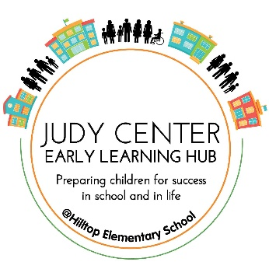

Judy Center at Hilltop Elementary

415 Melrose Avenue Glen Burnie, MD 21061

[www.JudyCenterHilltop.weebly.com](http://www.JudyCenterHilltop.weebly.com)

October News

Hello families! We hope that everyone is back in the swing of the school year and enjoying the beginning stages of Fall! This month we have several family night events, field trips, performances, and family engagement activities scheduled just for you. We will continue to have our weekly After School Arts Program, our Mental Health Check-Ins at Linthicum Library will begin this month as well as our Baby Pantry Pop-Up at the Glen Burnie Library. We also have our Trunk or Treat event where students get to trick-or-treat around Hilltop’s parking lot in their costumes and our Mobile Dentist visit. Please see below the dates and times for all these events. As always please contact us if you have any questions about our events.

Happy Fall!



**Upcoming Events**

* 10/17/19: Hilltop After School Arts Program  
   4-5:30pm at the Judy Center @ Hilltop Elementary
* 10/17/19: Mental Health Check-Ins at Linthicum Library 6-7:30pm
* 10/23/19: Chesapeake Children’s Museum visit for Judy Center 3-5 years old PAL group ONLY.
  + **Class this day will be from 9:30am-11:30am**
* 10/23/19: After School Arts Program 4-5:30pm
* 10/25/19: Trunk or Treat Event from 5-7pm
* 10/28/19: Mobile Dentist at the Judy Center   
  8am-4pm. Register at [www.MySchoolDentist.com](http://www.myschooldentist.com/)
* 10/30/19: After School Arts Program 4-5:30pm

**Upcoming Events**

* 10/7/19: Childcare Provider Visits to the Judy Center begin
* 10/7/19: After School Arts Program 4-5:30pm
* 10/8/19: PAL 0-2-year-old group begins
* 10/8/19: PAL 3-5-year-old group begins
* 10/8/19: Judy Center Baby Pantry Pop-Up at Glen Burnie Library 9:30am-11:30am
* 10/9/19: All Schools and Offices Closed
* 10/10/19: Tentative Heart Market at Hilltop 4-6pm
* 10/15/19 & 10/16/19: Parent/ Teacher Conferences, NO STUDENTS
* 10/16/19: Clark’s Elioak Farm Field Trip for PAL students ONLY

**Play and Learn Group Schedule (PAL)**

**Children 0-2 years old: Tuesday and Thursday from 9:30am-10:30am**

**Children 3-5 years old: Tuesday, Wednesday, Thursday from 11:00am-1:00pm**

**Contact Us!**

Jessica Kascic

Program Facilitator

[jkascic@aacps.org](mailto:jkascic@aacps.org)

443-603-5231

Tamira Dunn

Family Service Coordinator

[tndunn@aacps.org](mailto:tndunn@aacps.org)

443-852-2137

Savannah Stamates

Program Manager

[sstamates@aacps.org](mailto:sstamates@aacps.org)

410-562-1606